`
Thursday, September 4, 2025 | EAGLE’S PRIDE NEWS  Latest news and bulletin updates |  |  |  | Issue  #1
Laila Lamb, Edgar Tolorio Blake, Aniyah Robertson  WELCOME BACK, EAGLES  The latest updates  Welcome back to school eagles! We have now entered our 2025-2026 school year. Is anyone excited? I know some of our teachers are! We have so many things coming up so let us get some feedback from our eagle pride chief, Dr. Priestley and some of our main teachers Mrs. Staniszewski and Ms. Beard.  Mrs. Staniszewski feels like the first day brings a to-do list. She says, “Returning to school can be overwhelming, even after years of experience.” The first day of school is stressful for everyone but our teachers make it look effortless. She has been teaching for 31 years, so she has been lucky enough to instruct the children of her former students. This year, Mrs. Stan is focused on raising AP scores and striving for a 100% passing rate.    Josey Emblem pride and true Welcoming back students to another day. |  |  |  | 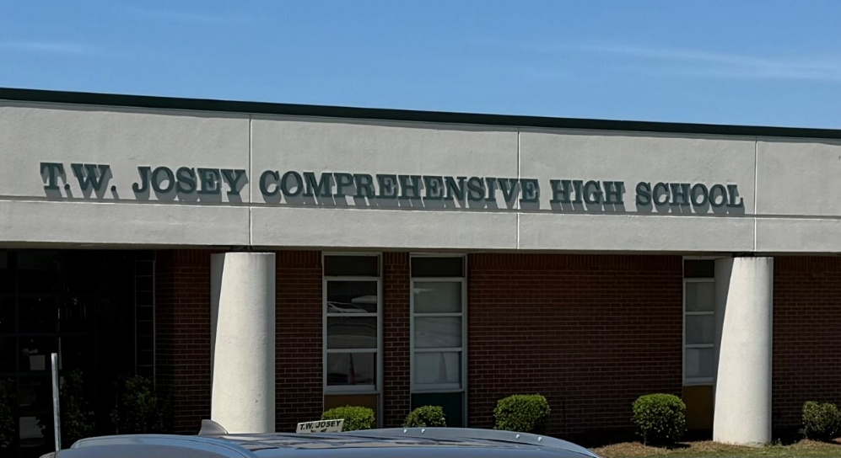
 |  |  |  | T.W. Josey standing tall .. A sign that will never fade.
According to Ms. Beard, her favorite thing about being a teacher is connecting with the energy of the kids and seeing their growth throughout the school year. She appreciates the welcoming atmosphere at T.W Josey, creating the exceptional leadership of the principal, administration, and resolute staff for creating a sense of home. Ms. Beard is also excited to cultivate positive relationships with her students.
According to Dr. Priestley, to him going back to school feels good. He says, “It's always good to have a summer break, but I like to interact with the students and seeing you guys' progress is a little bit more fun for me,” Isn't that awesome to have a principal who likes seeing his school rise?
Looking ahead, the insights obtained from these interviews suggest that Ms. Stan, Ms. Beard, and Dr. Priestley have a lot planned for this school year. Ms. Stan’s advice to freshman is to stay open-minded and do not be afraid to try new things. While Ms. Beard’s advice is to be open to growth and seek help when needed, she also encourages you to choose your friends wisely and learn from mistakes. Finally, Dr. Priestley advises freshman to stay focused, find your locker quickly and learn to open it fast. They may have different goals and advice, but they have one mission and that is to make sure students succeed and graduate from T.W. Josey Comprehensive High School.

Student Spotlight |  | Teacher Spotlight  Layla Lamb
IF YOU WOULD LIKE TO SHOUT OUT, PLEASE SUBMIT TO Ms. Crawford |  | With seven years of experience in education. Four years dedicated to classroom teaching and three years serving as a school principal. Mr. Vandalen is passionate about fostering a vibrant learning environment. Mr. Vandalen is currently teaching US History, World History and AP US History, He strives to make history engaging and meaningful for his students. His primary goal this year at Josey is to help build a culture of learning and excitement, inspiring students to see education as a powerful tool for change. Mr. Vandalen committed to creating a positive and dynamic classroom where curiosity thrives, and students feel motivated to achieve their best. He is our teacher highlight because he can make history more engaging with history beyond the classroom, fostering a lifelong interest in learning.  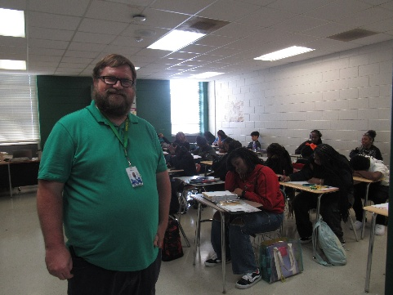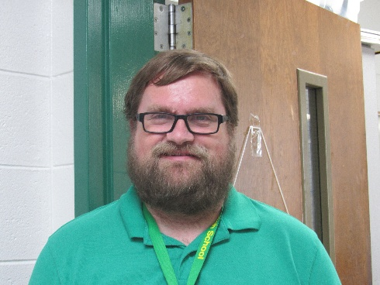  Mirjam Nilsson
Senior Spotlight |  | Beanstack Challenge  Mrs. Hall
IF YOU WOULD LIKE TO SHOUT OUT, PLEASE SUBMIT TO Ms. Crawford |  | 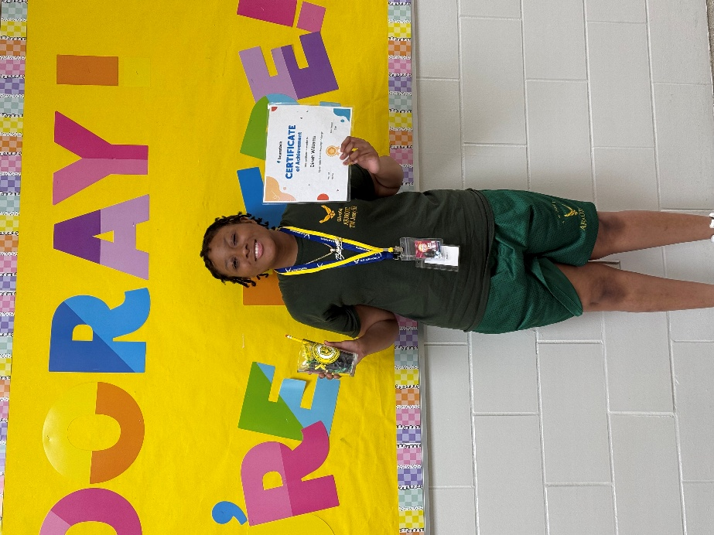  Congratulations  to Dinah Williams!  This summer, Dinah dove into reading through our Summer Reading “Splash into Stories” Beanstack Challenge. She went above and beyond by completing the challenge and logging over 600 minutes of reading! Way to go, Dinah—your dedication to reading sets a wonderful example for us all.  Remember, any reading counts toward Beanstack—books, magazines, or even comics. Log your minutes to earn badges and prizes as you grow your love for reading!

Thursday Sep 4, 2025 | LIFESTYLE & ENTERTAINMENT  NEWS TODAY |  | Issue #1
Jada Chapman
Lush Lash Studios
Business started by one of our own

Welcome to Lush Lashes Studio
We are enthusiastic about helping you achieve the perfect lashes and making you feel naturally stunning.

Our Mission
At Lush Lashes Studio, our mission is to provide high-quality, beautiful, and natural-looking lash extensions that enhance your beauty while keeping comfort in mind. We believe in creating a fun, welcoming environment for all our clients. Beauty should be enjoyable, which Is why we strive to make every visit relaxing and a positive experience. Our skilled technicians are dedicated to ensuring you leave feeling confident, radiant, and completely satisfied.

Where Beauty Meets Precision
We are thrilled to introduce you to our world of exquisite lash artistry—designed to highlight your natural beauty and boost your confidence. At Lush Lashes Studio, we believe every set of eyes tells a story, and our mission is to make yours unforgettable. Whether you prefer a soft, subtle look or bold, dramatic lashes, we customize each set to suit your unique style and personality.
Why Choose Us?

At Lush Lashes Studio, we do not just apply lashes—we create an experience. We want every client to feel valued, comfortable, and cared for from the moment they step through our doors. Lashes are more than just a beauty service—they are a confidence booster, a form of self-expression, and a way to feel like the best version of yourself. When you book with us, you are not just getting lash extensions –you are joining our lash family.

Connect With Us
Follow us on Instagram @lashesbythefines.jada & https://www.instagram.com/lashesbythefines.jada?igsh=ZzUyN2lqndVqemxs&utm_source=qr to see stunning lash transformations, enjoy exclusive promotions, and get valuable lash care tips. Booking is simple and convenient, so you can start your lash journey with ease.
Jade and Jaydah Galliard  Scary Movies…. “Yea or Nah”  Are Scary Movies worth watching anymore?  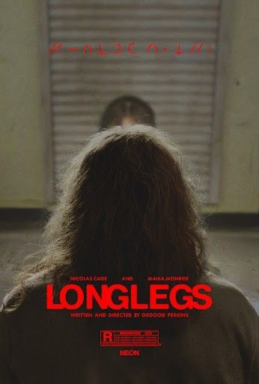 |  | In the movie scream (1996), the phone voice famously asks Sidney. who can’t act, who is always running upstairs when she should be running out the door.  Like ‘’Longlegs’’ it was confusing and did not catch our attention. The storyline feels slow instead of scary. I found myself waiting for something scary and exciting to happen, but it never really did. A good scary movie should grab your attention and make you nervous. But ‘’Longlegs’’ did nothing of that, that’s why we believe ‘’longlegs’’ is boring and not worth watching.  Scary movies are losing their spark because they rely on the same jump scares and they’re always overusing the same storylines. They need more, new fresh ideas and use creativity and true suspense that will keep us one the edge until then they will continue to feel repetitive and still overused storylines and still not frighten us.    ________________________________________  People could be drawn to scary movies for a variety of reasons. According to a study, it involves a combination of physiological responses, psychological benefits, and social experiences. One student said during an interview that it is the adrenaline rush they enjoy getting when watching a horror film, that it almost feels the same as riding a rollercoaster.  Some could also have individual differences, like people who are more empathetic may find it difficult to enjoy    horror movies because they strongly identify with the victim’s suffering. Others may use horror movies to practice coping with negative emotions such as fear and anxiety, in a simulated setting.  The real reason people love scary movies is simple: they let us face our darkest fears without ever leaving the couch. After all, when the credits roll, the monsters stay on screen.  Citing’s  · Fight-or-Flight, neurochemistry, and the thrill of fear. CSP Global explains how horror, even as entertainment, can trigger adrenaline, dopamine, endorphins, and since the viewers are safe, the brain turns fear into an enjoyable rush.  · Psychology Today: suspense, physiological response, catharsis. It discusses how fear and excitement mix in horror films. Talks about that roller coaster rush that creates a rewarding experience through suspense and catharsis.  · The Protective Frame Theory. John’s Hopkins research outlines how watchers enjoy horror when they feel safe, detached, and in control.
When you feel like you're getting poked with a needle that’s when you know Bathsheba Sherman is nearby. Do you think scary movies are getting boring? These days, it feels like horror films rely on the same predictable jump scares and recycled storyline we’ve seen a hundred times before. The thrill is fading and what used to make us grip our seats now barely makes us flinch. If the genre doesn’t start taking risks and creating fresh, original ideas, scary movies might lose the power to scare us.

Mayrin Montoya

THE PSYCHOLOGY OF FEAR
The latest updates to get you through the day
Why do people enjoy scary movies even though they cause fear and anxiety? Some could say they love scary movies, but they are also the first to hide behind a pillow during the scariest scenes. Others admit they enjoy the rush of adrenaline that comes with a good scare. So, what is it about fear that keeps audiences so addicted?

Thursday, September 4, 2025 | SPORTS NEWS TODAY |  |  |  | Issue  #1
Maliya Bush, Tikira Scurry  Which is worth more fashion or sports   |  | inspiring, luxury designers and streetwear brands alike    . The blurring lines between athletic wear and everyday fashion have created a lucrative market for “athleisure” products and related content, according to ATL plus magazine. The blurring lines between athletic wear and everyday fashion have created a lucrative market for “athleisure” products and related content, according to ATL plus magazine.  While many sports have shaped this way, we dress basketball has had the greatest impacts on fashion trends because of its close ties to streetwear culture, the raise of global sneakers obsession and the style influence of superstar athletes whose looks resonate for beyond the game. The global fashion industry is a multi-million-dollar sector, representing a considerable portion of global G.D.P in the United States alone, the industry employed over 1.8 million people and consumer spent $380 billion on apparel and footwear in 2017. The demonstration of the industries widespread impact on job creation. |  | 
Sports have long been more than just games they are powerful drives of culture. The gear athletes wear for performance after inspires what people wear on the street.
Tennies introducing crisp, all-white ensembles in the early 20th century to skateboarding popularizing has left its fashion footprint. Yet some have gone beyond influencing trends, they have transferred entire industries, inspiring, luxury designers and streetwear brands alike
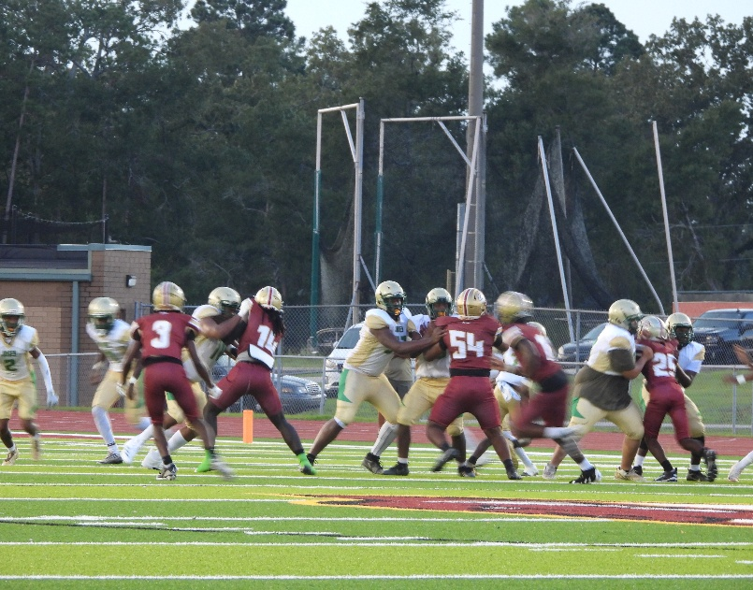
On the right is a sweett tackle from Josey. On the left is the beginnng line up.
Eagle News Staff

Eagles Show Heart in Season Kickoff
Both Volleyball and Football off to a good start
The T.W. Josey Eagles returned to the field this week with a scrimmage game against the CC Razorbacks that proved to be more than just football—it was a statement of perseverance, teamwork, and Eagle pride.  Although the scoreboard reflected a 22–12 Razorbacks victory, the Eagles demonstrated resilience from start to finish. With 1:48 left in the fourth quarter, Josey had possession, fighting for a comeback that showed their never-give-up spirit. Even with just 46 seconds remaining and only inches away from the finish line, the Eagles kept pushing forward.  Moments of Determination  The night was not short of challenges. Four costly interference penalties and multiple called-back touchdowns slowed Josey’s momentum, but the players refused to let setbacks define the game. Injuries tested the team’s depth, yet the Eagles pressed on, scoring two touchdowns and showing flashes of the strong season ahead.  Off the field, the energy in the stands was electric. The Josey dancers lit up the sidelines with stunning performances, keeping fans engaged and spirits high. Displays of good sportsmanship from both teams reminded.  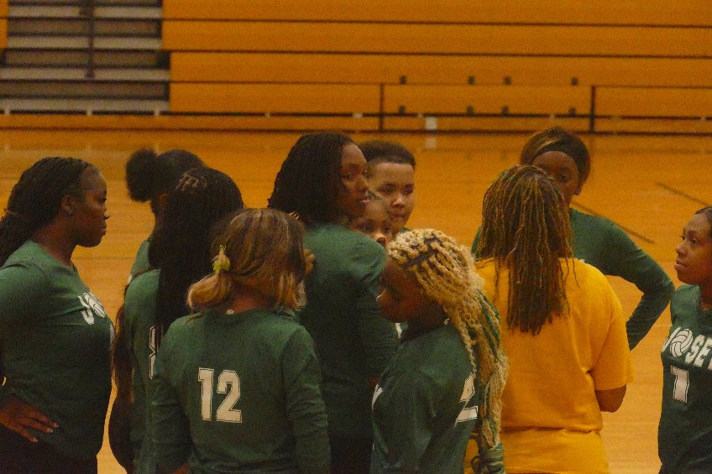 |  |  | everyone what the game is truly about—competition, community, and character.  Coach Clemons Speaks on Lessons Learned  Head Coach Clemons reflected on the scrimmage as a critical learning opportunity:  “It was a great first game. A lot of these young men were getting their first experience out here playing. We made just a couple more mistakes that cost us dearly. We had four touchdowns called back for penalties—you are not going to win games like that. But it is a great learning experience. Whether the penalties were justified or not, we still must deal with it. That is part of football, part of growing.”  Clemons emphasized accountability and sportsmanship:  “They know I am going to hold them accountable. It does not matter who you are—you’re going to do it the right way. That is what’s expected. We have a bye week next week, and that is a great opportunity to reset and focus on fundamentals. By our second game, I believe people will look at this team and see that we are the better team. We just must stop shooting ourselves in the foot.”  Coach Chapman on the Lady Eagles’ Energy  On the sidelines, the Lady Eagles Cheer and Dance squads also made their season debut. Coach Chapman praised their effort and positive energy:  “The girls are looking good. Right now, we are focusing on fundamentals and team unity. They have even created some cheers to keep each other positive. I really want to pull them together and build their communication. They are starting off strong.”  Looking Ahead  While the scoreboard did not swing in Josey’s favor, the scrimmage was far from a loss. The Eagles showed toughness, determination, and growth—qualities that will carry them through the season. With time to regroup during the bye week, fans can expect an even stronger showing in the next matchup.  This is more than just the start of a football season—it is the beginning of a year filled with Eagle pride, resilience, and determination. The message is clear: Never give up. Keep your head up. Straight to a beautiful year.

Thursday, September 4, 2025 | FASHION NEWS |  |  |  | Issue #1



Look at the fashion over the years.
WELCOME BACK FASHION TRENDS FROM THE 90’S 2.0
Narrissa
How come Cardi B’s latest fashion trends are from 20 years ago, Where's the outlet? What makes her latest clothing style so hyped? It is surprising how people from the 20s find a liking or similar styles from the 90s feel about the old trendy clothing styles making a comeback. Do people from their 20s? They started an uprising where came back to a trend before that time. Nowadays people from the 20s often wear more trendy clothes from the 90s such as baggy jeans, crop tops, jerseys of any sports team, Timlin boots and graphic T-shirts. When wearing clothing trends from the 90s, do people from the 90s feel surprised to see it come back to their old clothing trends?  20 years ago, people from the 90s wardrobes were like changing clothes. also how come music artist Belcais Almanzer Also known as Cardi B. Cardi B has taken a set back from clothing trend from the 20s and has started back wearing clothing trends from the bygone era. I just made chocolate cake. Chinese food Is it that Cardi B is experiencing a moment of nostalgia? Cardi B's most popular outfit choices previously were sourced by Fashion Nova Sheen and her longtime stylist, |  |  | who is known for bringing out her hidden characteristics and inter self through old fashion. Cardi latest outfits were originally posted on her numerous social media social apps in the post she was seen to be wearing a graphic long sleeve baggy jeans and Jordan fours in a shade of reddish orange. Although cardi B was born in the 90s She has now started to influence others into making a statement to old clothing trends from the 90s. Cardi's stylists often worries about certain clothing styles and Cardi, so cardi only wears several clothing brands most of the time. When Cardi feels like dressing herself, she often wears baggy clothing, lately Cardi has been going further into the bygone era on her page recently, her daughter has been taking a liking to her mother's new outfit choices. Kulture has taken a liking in the way people from the 90s have somewhat long acrylic nails. Cardi’s outfits recently are aesthetically fashionable because she chose to go back to an era from her time to not only express herself but to give her followers, fans, and others around her she finds her guidance in her peoples.

Thursday, September 4, 2025 |  | SCHOOL NEWS |  |  |  | Issue #1

2025

Josey Gears Up for Homecoming Week 2025!
  Mrs. Huff | Let’s get ready for 2025 Homecoming!! |  |  | T. W. Josey High School is getting ready to celebrate Homecoming 2025 with a week full of spirit, pride, and tradition. Students, alumni, families, and the entire Augusta community are invited to join in the festivities beginning Monday, September 15, 2025.
👑 Coronation Night  One of the most anticipated events of the week will take place on Wednesday, September 17, at 6 p.m. in the new gym. The Homecoming Court will be crowned in a dazzling Coronation ceremony that promises elegance, excitement, and plenty of Eagle spirit.  🔥 Pep Rally Power  Friday is all about energy and unity! Students and staff will pack the gym for the Homecoming Pep Rally, where the Eagle Nation will come together to cheer on the football team, showcase school pride, and kick off the weekend in style.  🎉 Saturday Spectacular  Saturday is jam-packed with tradition, fun, and community:  - Tailgating: 7 a.m. – 7 p.m. (all-day food, music, and fellowship)  - Parade: 11 a.m. – Downtown Augusta will come alive with floats, bands, and community groups.  - Homecoming Game: 2 p.m. – The Josey Eagles take the field in front of a roaring crowd.  🦅 Eagle Pride on Display  From the first day of activities to the final whistle of the Homecoming game, the week will be a celebration of school spirit, unity, and community pride. Whether you’re a current student, a proud alum, or a dedicated fan, this Homecoming week promises memories that will last a lifetime.  So, mark your calendars, wear your green and gold, and get ready—Josey Homecoming 2025 is here!  __________________________________________    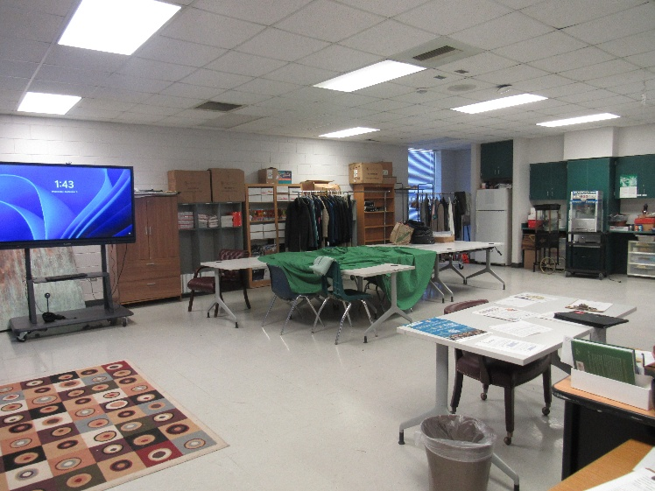 |  |  |  | “Homecoming isn’t just about a game—it’s about celebrating our past, embracing our present, and soaring into the future. Once an Eagle, always an Eagle!”  - Ms. Crawford
Eagle Staff
Welcome Back: Spotlight on the Parent Resource Center at T.W. Josey
As the new school year begins, T.W. Josey High School is excited to remind families and community members about one of its most valuable supports—the Parent Resource Center. More than just a space, the center serves as a bridge connecting students, parents, and the community to vital tools that promote learning and growth.
What is the Resource Center?
Mr. McKinnie, a dedicated leader at Josey, explained the purpose of the center:
“It is a center where parents, students, and community members go to get what they need if they don’t have their own resources.”
From school supplies to community information, the center is designed to ensure no family feels unsupported.
Why the Center Matters
The need for such a space is rooted in community care. For Mr. McKinnie, the mission goes beyond materials:
“For the community and because I’ve been doing it for more than 20 years. It just feels right.”
This long-standing dedication underscores the importance of providing a place where families can turn during times of need.
Heart for the Community
For Mr. McKinnie, the work is more than a job—it’s a calling:
“I see the good and the bad from the students and the community, and I am here for it all, but most importantly, I enjoy helping my community and being here with Josey, brightening my days.”
The center embodies the Eagle spirit, reminding everyone that T.W. Josey is not just a school—it’s a family.
A Lesson Learned
Through decades of service, Mr. McKinnie has discovered an important truth:
“That in every walk of life there’s a need!”
This message captures the heart of the Parent Resource Center—meeting families where they are, with compassion and support.
Moving Forward Together
As the year begins, parents and guardians are encouraged to make use of the Resource Center. Whether it’s academic support, supplies, or simply encouragement, the center is here to uplift the Eagle community.
At T.W. Josey, education is more than academics—it’s about building a stronger, more connected community. The Parent Resource Center is proof of that commitment.
Welcome back, Eagles—let’s make this year one of growth, unity, and pride!

Thursday, September 4, 2025 | STUDENT SUBMISSIONS NEWS | Issue #1

A Long Way from Normal!

By: Unnormal Mew

Gone Fishing Jordyn OliverTolorio

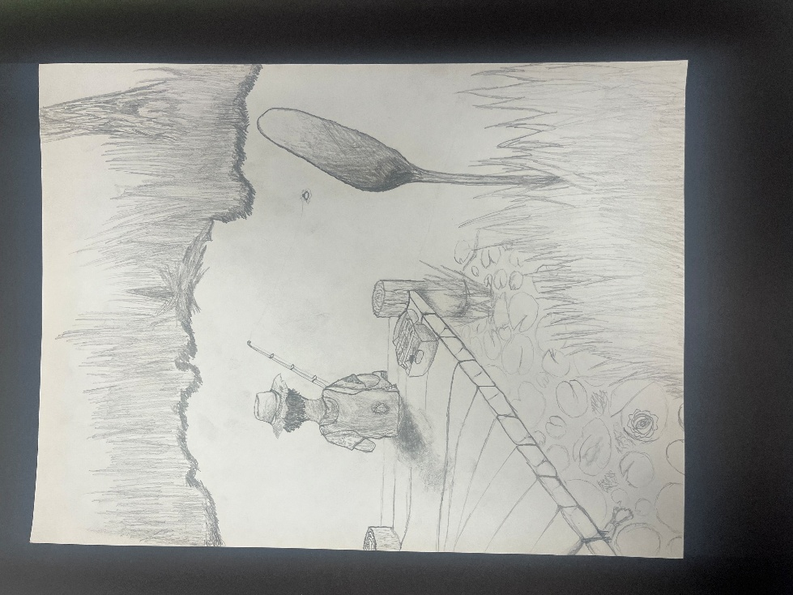
Thursday, September 4, 2025 | OPINION NEWS |  |  |  | Issue #1


COLLEGE OR FREEDOM
The latest updates to get you through the day
Morgan Frazier  Have you ever wondered what should I do after high school? Here is one reporter’s opinion!  What if the smartest move you could make after graduation was to stop? Not quit but just take a moment to enjoy the sweetness and bitterness of life. Give yourself time to just live in the moment. Trade the pressure for 12 months of finding your purpose, and step onto campus not as a confused freshman, but as a confident, unstoppable you.  Save time in Word with new buttons that show up where you need them. To change the way a picture fits in your document,   |  |  | click it and a button for layout options appears next to it.  When you work on a table, click where you want to add a row or a column, and then click the plus sign. Reading is easier, too, in the new Reading view. You can collapse parts of the document and focus on the text you want.  When I interviewed Ms. Crawford, she explained that during her gap year she worked and shopped, but more importantly she learned how to manage money, be independent, and figure out who she wants to be. She said that time really shaped her into her own person. Ms. Harvey shared that she also took a gap year back in 2019 because she wasn't sure what she wanted to do. For her the break gave her time and space to think about her future before making a big decision. Taking a gap year can give people a chance to take things slow, focus on themselves, and make choices without rushing.  So, I suggest you take a gap year. Especially the people who live by the saying YOLO!!!

